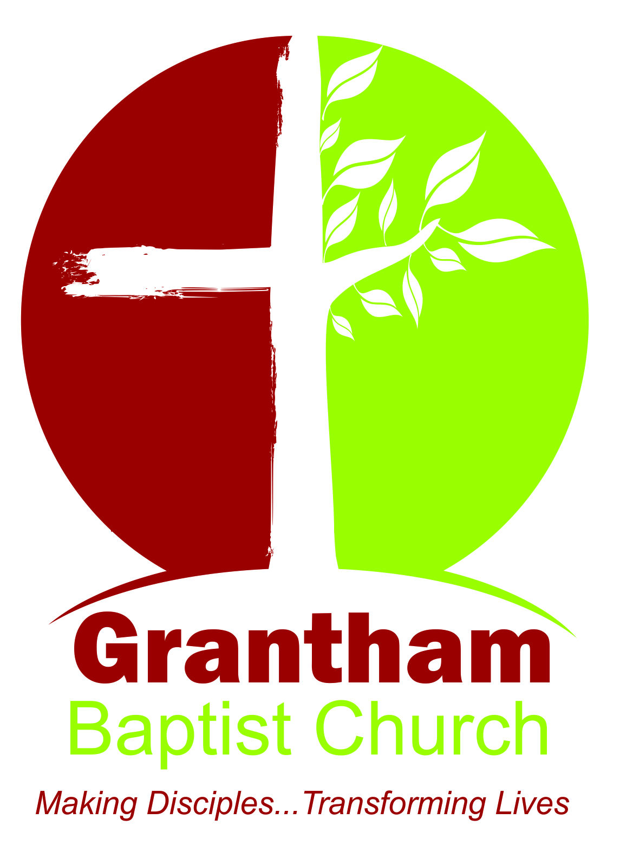

**Church Consent Form**

Surname…………………………………………………………………………………………………

Adult’s name(s)………………………………………………………………………………………

Children’s name(s)……………………………………………………………………………………

…………………………………………………………………………………………………………………

Address…………………………………………………………………………………………………….

…………………………………………………………………………………………………………………

…………………………………………………………………………………………………………………

Telephone (home)…………………………………………………..… Ex-Dir Y/N ….…

(mobile)……………………………………………………………………………………………………

Email………………………………………………………………………………………………………..

Your privacy is important to us, and we want to communicate with the church congregation in a way which has their consent, and which is in line with UK law on data protection. As a result of a change in UK law, we now need your consent as to how we contact you.

By signing this form you are confirming that you are consenting to Grantham Baptist Church (GBC) holding and processing your personal data for the following purposes (please tick the boxes where you grant consent):-

I consent to the church contacting me by 🞏 post 🞏 phone or 🞏email.

🞏 To keep me informed about news, events, activities and services at GBC

🞏 To send out the Church Family Meeting Minutes

🞏 To including my details in the ‘Church Directory’ which is circulated to the congregation and to share my details between the groups within GBC

I confirm that I have received a copy of GBC’s Privacy Notice.

Signed: **____________________** Signed: **____________________** Dated: **__________________**

You can grant consent to all the purposes; one of the purposes or none of the purposes. Where you do not grant consent, we will not be able to use your personal data; (for example, we may not be able to let you know about forthcoming services and events); except in certain limited situations, such as where required to do so by law or to protect members of the public from serious harm. You can find out more about how we use your data from our “Privacy Notice” which is available from our website or from the Church Office.

You can withdraw or change your consent at any time by contacting the Church Office at Grantham Baptist Church, Wharf Road, Grantham, Lincs, NG31 6BA or g.b.c_ad@outlook.com. Please note that all processing of your personal data will cease once you have withdrawn consent, other than where this is required by law, but this will not affect any personal data that has already been processed prior to this point.

*Grantham Baptist Church is a registered charity number 1133324*